Software Requirements Specification

for

Appliances Retailer Management

**Version 1.0 approved**

**Prepared by Duc Tho Tran – Hoan Thien Nguyen**

**Group 6**

**09-10-2018**

**Table of Contents**

1. Introduction 4

1.1 Purpose 4

1.2 Document Conventions 4

1.3 Project Scope 4

1.4 References 4

2. Overall Description 4

2.1 Product Perspective 4

2.2 User Classes and Characteristics 5

2.3 Operating Environment 6

2.4 Design and Implementation Constraints 7

2.5 Assumptions and Dependencies 7

3. System Features 7

3.1 Login 7

3.1.1 Description 7

3.1.2 Functional Requirement 7

3.2 Logout 8

3.2.1 Description 8

3.2.2 Functional Requirement 8

3.3 Manage staffs 9

3.3.1 Description 9

3.3.2 Functional Requirement 9

3.4 Manage policies 11

3.4.1 Description 11

3.4.2 Functional Requirements 11

3.5 Manager product list 13

3.5.1 Description: 13

3.5.2 Functional Requirements 13

3.6 Produce statistic data on promotion policy 15

3.6.1 Description 15

3.6.2 Functional Requirements: 15

4. Data Requirements 16

4.1 Logical Data Model 16

4.2 Data Dictionary 16

4.3 Reports 20

4.4 Data Acquisition, Integrity, Retention, and Disposal 22

5. External Interface Requirements 23

5.1 User Interfaces 23

5.2 Software Interfaces 23

5.3 Communications Interfaces 23

6. Quality Attributes 23

6.1 Usability 23

6.2 Performance 23

6.3 Security 24

6.4 Availability 24

**Revision History**

|  |  |  |  |
| --- | --- | --- | --- |
| **Name** | **Date** | **Reason For Changes** | **Version** |
| Hoan Thien Nguyen | 19-10-2018 | Initial part 1 | 1.0 draft |
| Duc Tho Tran | 22-10-2018 | Initial part 2, 3 | 1.0 draft |
| Hoan Thien Nguyen | 22-10-2018 | Intital part 4 | 1.0 draft |
| Duc Tho Tran | 25-10-2018 | Intial part 5 | 1.0 draft |
| Hoan Thien Nguyen | 25-10-2018 | Intial part 6 | 1.0 draft |
| Duc Tho Tran | 25-10-2018 | Review | 1.0 approved |

# Introduction

## Purpose

This SRS describes the functional and nonfunctional requirements for software release 1.0 of the Appliances Retailer Management (ARM). This document is intended to be used by the members of the project team who will implement and verify the correct functioning of the system

## Document Conventions

No special typographical conventions are used in this SRS.

## Project Scope

The ARM is an application that helps decrease operating cost and increase efficient working time in Nguyen Kim System. A detailed description is available in *the Appliances Retailer Management Vision and Scope Document* [1], along with the features that are scheduled for full or partial implementation in this release.

## References

1. Duc Tho Tran - Hoan Thien Nguyen. *Appliances Retailer Management Vision and Scope Document*
2. Duc Tho Tran - Hoan Thien Nguyen. *Appliances Retailer Management Use cases*

# Overall Description

## Product Perspective

The Appliances Retailer Management is a new software system that increases staffs’ efficient time, decreases operating cost and inventory number. The context diagram in Figure 1 illustrates the external entities and system interfaces for release 1.0.

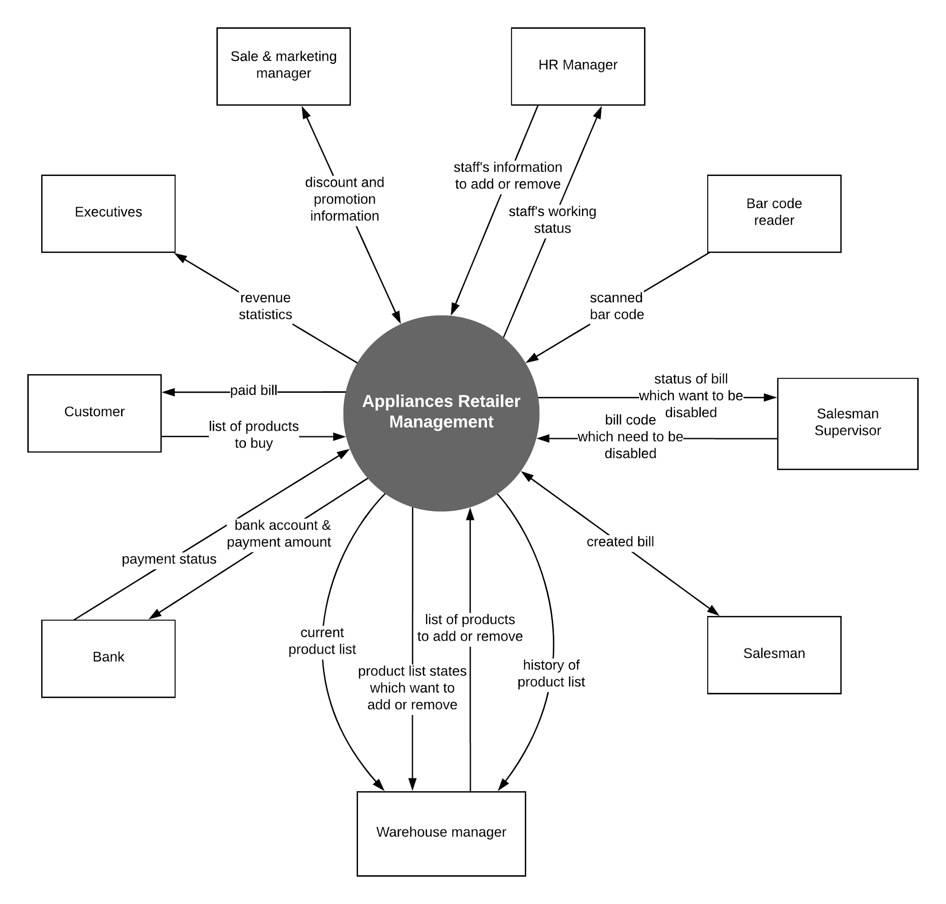

**Figure 1.** Context diagram for release 1.0 of the Appliances Retailer Management System.

## User Classes and Characteristics

|  |  |
| --- | --- |
| **Sale & Marketing Manager** | The Sale & Marketing Manager is the person who makes the proposal and is responsible for applying the promotion, discounts for the company's product lines after approval from the executive board. Applying promotions and discounts to increase the credibility and popularity of the product line to consumers. |
| **Warehouse Manager** | The person responsible for managing the warehouse, supervising the import and export and recording the activities into the system. Each warehouse manager manages only one corresponding repository. At present, there are 11 repositories, so the Nguyen Kim system has 11 warehouse managers. Warehouse managers will make it easier to perform inventory control operation and orientation of products from the operator. |
| **HR Manager** | The person who is responsible for recruiting staff when there is a human resource problem. Typically, when the Nguyen Kim company opens more branches or stores, then will lack human resources and HR Manager will perform their responsibilities. In addition, HR Manager performs the duty of keeping track of employees' work progress or even dismissing employees. |
| **Salesman** | Salesman are people who directly perform billing work, approve payments with customers in cash or even debit cards. Further, salesman also have to advise customers about the product that customers want to buy. Currently, there are 20 - 25 sales staff for each branch of the Nguyen Kim system. |
| **Salesman supervisor** | As in the business requirements and actuality in the company, the number of sales staff in each store will be divided into groups of 4 to 6 people for salesman supervisor to manage. Salesman supervisor will monitor the salesman to ensure that the work is done correctly, minimize mistakes made by salesman when accepting invoices, and limit theft. |
| **Administrator** | Person in the executive board or equivalent positions have the authority to monitor the system, view the revenue statistics as well as executing other managerial rights such as sales & marketing manager, warehouse manager and HR manager on the system. |

## Operating Environment

* OE-1. The ARM shall operate correctly on Windows 7 or upper.
* OE-2: The ARM shall operate on a server running the current corporate-approved versions of Red Hat Linux and Apache HTTP Server.

## Design and Implementation Constraints

* CO-1: The system shall use the current corporate standard SQL Server database engine.
* CO-2: All HTML code shall conform to the HTML 5.0 standard.
  1. Assumptions and Dependencies
* AS-1: The company has enough the means and equipment to operate the system.
* AS-2: Increasing employee efficiency at work will result in increasing the frequency of customer interaction.
* AS-3: Each store has only one warehouse.

# System Features

* 1. Login
     1. Description

The user wants to log on to the system with a registered role to perform their tasks and use system resources.

* + 1. Functional Requirement

|  |  |  |
| --- | --- | --- |
| login.form: | The system will display the interface to fill in the login information. From there, if the login information is correct, the system will allow users to login corresponding to their role.The login interface includes:   1. Login label and logo of Nguyen Kim 2. Username input box. 3. Password input box. 4. Submit button. | (Priority=H) |
| login.submit: | Information from the user including username and password will be submitted to the system and stored to perform the check login function. | (Priority=M) |
| login .check-login: | The system checks the database for whether the submitted username and password pair exists. | (Priority=H) |
| login .login-success: | When the submitted username and password pair is existed and the account is still valid, that means the user login successfully. Login data will be saved to session scope within 120 minutes, stored information including user’s information, login time, device login and location. | (Priority=M) |
| login .login-fail: | When the user login failed, system will announce the message to the user reason for not successful login. | (Priority=M) |
| login .login-fail .message: | Messages that failed to log in include:   1. Account has been disabled, no longer valid. 2. Invalid username or password. | (Priority=L) |

* 1. Logout
     1. Description

The user wants to log out, not use system resources anymore.

* + 1. Functional Requirement

|  |  |  |
| --- | --- | --- |
| logout.button: | The system will always show a logout button on the application window, users can log out at any time. | (Priority=L) |
| logout. clear-session: | The system clears all data in the session scope. | (Priority=H) |

* 1. Manage staffs
     1. Description

HR manager or administrator shall be able to manager all staffs in the company of any brand on the system. Management tasks include adding new a staff, deleting a staff, and viewing employee’s information.

* + 1. Functional Requirement

|  |  |  |
| --- | --- | --- |
| **staffs .manage .form:** | The interface is designed so that users can easily perform employee management tasks, including:   1. Manage label Nguyen Kim logo. 2. Employee identification code and full name of person performing the management task. 3. An input box to search for employees. 4. A table showing the corresponding employee list includes some information such as employee identification code, full name and date of birth. 5. Add a new staff button. 6. Delete a staff button. 7. View a staff button. | (Priority=H) |
| .search: | When users enter data into the search input box, the data in the table will be changed to match the search results. The search input box is only used to search for employees by their employee identification code or full name, | (Priority=L) |
| **staffs .manage .add:** | If the add new button is clicked, a new window will pop up containing the text fields corresponding to the employee information, the user will have to fill in the new employee information. | (Priority=M) |
| .form: | Include text fields to fill in information about the new employee, each text field will have a corresponding label next to:   1. Username text input box (required, unique) 2. Password field (required) 3. Re-password field (required) 4. Full name text input box (required) 5. Email address input box (required) 6. Gender radio group:    1. Male radio button (default)    2. Female radio button 7. Address field (optional) 8. Phone number input box (required) 9. Role combobox (default: salesman) 10. Other note (optional) 11. Submit button | (Priority=M) |
| .form .valid .username: | The system shall display an error message if the username that the user enters is missing, not properly formatted or is existed. A valid username contains only letters and numbers, the username length should be between 6 - 20 characters. | (Priority=L) |
| .form .valid .password: | The system shall display an error message if the password that the user enters is missing or not properly formatted. A valid password contains only letters and numbers, the username length should be between 6 - 20 characters. | (Priority=L) |
| .form .valid .re-password: | The system shall display an error message if the repassword that the user enters is not match with password field. | (Priority=L) |
| .form .valid .email: | The system shall display an error message if the email address that the user enters is missing or not properly formatted. A valid email address contains only letters and numbers, must contain exactly one “@” following one or more characters, must contain exactly one period following the “@” with any number of intervening characters, and must have at least one character following the period. | (Priority=M) |
| .form .valid .fullname: | The system shall display an error message if the full name text field is empty. | (Priority=L) |
| .form .valid .phone-number: | The system shall display an error message if the phone number text field is empty. | (Priority=L) |
| .form .submit: | When submit button is clicked, all staff information after valid without errors will be stored in the system, a successful message will be displayed to inform the user. | (Priority=L) |
| .form .cancel: | Add new employee form will disappear, employee management form will be focused. | (Priority=L) |
| **staffs .manage .delete:** | After the user selects the employee to delete in the table and clicks the delete button, the system will no longer display that employee information, the employee's account will be disabled. | (Priority=M) |
| **staffs .manage .view** | After the user selects the employee to view information in the table and clicks the view button, a window will show all information of the employee. | (Priority=M) |
| .cancel | View employee form will disappear, employee management form will be focused. | (Priority=L) |

* 1. Manage policies
     1. Description

Sale & marketing manager or administrator shall be able to manager all of the discount and promotion policies in the company of any brand on the system. Management tasks include adding new policy, stopping a policy and viewing a policy information.

* + 1. Functional Requirements

|  |  |  |
| --- | --- | --- |
| **policies**  **.manage**  **.form:** | The interface is designed so that users can easily perform policy management tasks, including:   1. Manage label Nguyen Kim logo. 2. Employee identification code and full name of person performing the management task. 3. An input box to search for policy. 4. A table showing the corresponding policy list includes some piece of information such as policy identification code, policy name, start date and end date. 5. Add a new policy button. 6. Stop a policy button. 7. View a policy button. | (Priority=H) |
| .search: | When users enter data into the search input box, the data in the table will be changed to match the search results. The search input box is only used to search for policies by their policy identification code or policy name, | (Priority=L) |
| **policies .manage .add:** | If the add new button is clicked, a new window will pop up containing the text fields corresponding to the policy information, the user will have to fill in the new policy information. | (Priority=M) |
| .form: | Include some fields to fill in information about the new policy, each field will have a corresponding label next to:   1. Policy identification field (automatically generated, editable, unique, required) 2. Policy name input box (required, unique) 3. Start date picker (default: current date) 4. End date picker (required) 5. Other note (optional) 6. Submit button | (Priority=M) |
| .form .valid .id: | The system shall display an error message if the policy identification that the user enters is missing, not properly formatted or is existed. A valid policy identification contains only letters and numbers, the policy identification length should be between 6 - 20 characters. | (Priority=L) |
| .form .valid .name: | The system shall display an error message if the policy name that the user enters is missing or is existed. | (Priority=L) |
| .form .valid .end-date: | The system shall display an error message if the end date that is not picked a date or the end date is before the start date. | (Priority=M) |
| .form .submit: | When submit button is clicked, all information after valid without errors will be stored in the system, a successful message will be displayed to inform the user. | (Priority=L) |
| .form .cancel: | Add new policy form will disappear, policy management form will be focused. | (Priority=L) |
| **policies .manage .stop** | After the user selects the started policy to stop in the table and clicks the stop button, the policy will no longer applied. | (Priority=M) |
| **policies .manage .view** | After the user selects the policy to view information in the table and clicks the view button, a window will show all information of the policy. | (Priority=M) |
| .cancel | View policy form will disappear, policy management form will be focused. | (Priority=L) |

* 1. Manager product list
     1. Description:

Warehouse manager or administrator shall be able to manager all products in the warehouse. Management tasks include adding a list of products, removing a list of products and viewing a product information.

* + 1. Functional Requirements

|  |  |  |
| --- | --- | --- |
| **products .manage .form:** | The interface is designed so that users can easily perform product management tasks, including:   1. Manage label Nguyen Kim logo. 2. Employee identification code and full name of person performing the management task. 3. An input box to search for product. 4. A table showing the corresponding product list includes some piece of information such as product identification code, product name, recent import date and quantity. 5. Add-new-a-list-of-products button. 6. Remove-a-list-of-products button. 7. View a product button. | (Priority=H) |
| .search: | When users enter data into the search input box, the data in the table will be changed to match the search results. The search input box is only used to search for products by their product identification code or product name, | (Priority=L) |
| **products .manage .add:** | If the add new button is clicked, a new window will pop up containing the text fields corresponding to the product list information, the user will have to fill in the new product list information. | (Priority=M) |
| .form: | Include some fields to fill in information about the list of products, each field will have a corresponding label next to:   1. Add date picker (default: current date) 2. Description input box (optional) 3. A table showing the recently added product list. 4. Add product panel:    1. Product identification code (required)    2. Product name text field (required, autofill if existed product identification code)    3. Quantity number field (required)    4. Add to recent product list button. 5. Submit button | (Priority=M) |
| .form .valid .product-list: | The system shall display an error message if there is nothing in the recent product list. | (Priority=L) |
| .form .product-list. product.valid.id: | The system shall display an error message if the product identification code is empty. | (Priority=L) |
| .form .product-list .product.valid.name: | The system shall display an error message if the product name is empty. | (Priority=L) |
| .form. product-list .product.valid .quantity: | The system shall display an error message if the product name is not a positive number or empty. | (Priority=L) |
| .form .submit: | When submit button is clicked, all information after valid without errors will be stored in the system, a successful message will be displayed to inform the user. | (Priority=L) |
| .form .cancel: | Add new product list form will disappear, product management form will be focused. | (Priority=L) |
| **products .manage .delete:** | After the user selects the product to delete in the table, input the quantity for each product to delete and clicks the delete button, the system will subtract the recently deleted quantity of goods in product list for each product. If the quantity product equal to zero, the system will no longer display that product. | (Priority=M) |
| **products .manage .view:** | After the user selects the product to view information in the table and clicks the view product button, a window will show all information of the product. | (Priority=M) |
| .cancel: | View product form will disappear, product management form will be focused. | (Priority=L) |

* 1. Produce statistic data on promotion policy
     1. Description

Marketer shall be able to get statistic data on promotion policy

* + 1. Functional Requirements:

The system will produce statistic data on promotion policy monthly, then send the data to marketers.

# Data Requirements

## Logical Data Model

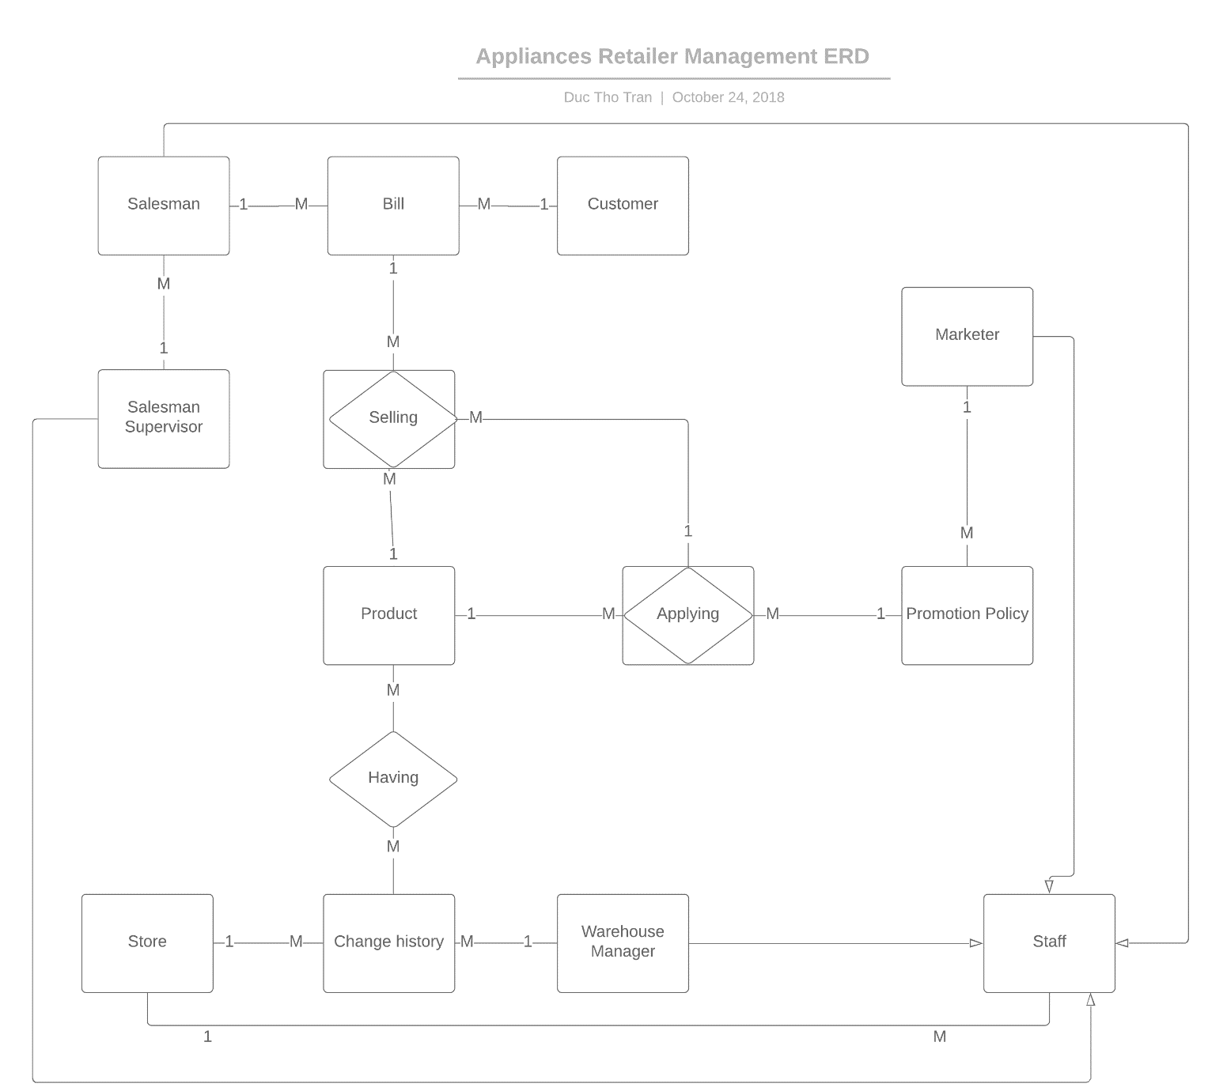

**Figure 2.** Partial data model for release 1.0 of the Appliances Retailer Management.

## Data Dictionary

**Store** (storeID, storeName, storeAddress)

**Staff** (staffID, staffPassword, staffFirstName, staffLastName,staffPhone,staffRole, storeID)

**Customer** (customerPhone, customerName, customerAddress, customerPoint, customerType)

**Product** (productID, storeID, productName, productQuantity, productPrice, producer, storeID)

**Bill** (billID, billDate, staffID, customerID)

**Promotion** (promotionID, staffID, fromDate, toDate, promotionDescription)

**PromotionDetails** (promotionID, productID, discountPercent, customerType)

**Selling** (productID, sellingQuantity, sellingPrice, billID, promotionID)

**ChangeWarehouse** (changeID, storeID, staffID, changeWarehouseDescription)

**ChangeWarehouseDetails** (changeID, productID, changeQuantity)

|  |  |  |  |
| --- | --- | --- | --- |
| **Data Element** | **Description** | **Composition or Data Type** | **Length** |
| StoreID |  | string | 20 |
| StoreAddress |  | string | 200 |
| StaffID |  | His/her first name + the first letter of his/her family name+ DeptID+ nth | 15 |
| StaffPassword | Must be at least 8 letters, must include lowercase, uppercase characters and digit | string | 30 |
| StaffFirstName |  | string | 30 |
| StaffLastName |  | string | 30 |
| StaffPhone |  | string | 10 |
| StaffRole | Must be “salesman” or “warehouseManager” or “marketer” or “executive” | string | 10 |
| CustomerID | His/her phone | string | 10 |
| CustomerName |  | string | 50 |
| CustomerAddress |  | string | 100 |
| CustomerPoint | The points each customer gains every time he/she buy items | int |  |
| CustomerType | The type of this customer | string | 20 |
| BillID | Primary key, auto increment | long |  |
| BillDate | The date when this bill is printed | datetime |  |
| StoreID |  | string |  |
| ProductID | Primary key, auto increment | string | 10 |
| ProductName |  | string |  |
| ProductQuantity | The number of product left | int |  |
| ProductPrice | Normal price to sell this product | float |  |
| Producer | Producer of a product | string |  |
| PromotionID | Primary key, auto increment | int |  |
| PromotionFromDate |  | date |  |
| PromotionToDate |  | date |  |
| promotionDescription | Why do we have this promotion? | string | 500 |
| DiscountPercent |  | float |  |
| SellingQuantity | Number of ProductID be sold | int |  |
| SellingPrice | Price of ProductID be sold (1-DiscountPercent)*ProductPrice | float |  |
| changeID | Primary key, auto increment | int |  |
| changeWarehouseDescription | Short description of changes | string | 500 |
| changeQuantity | Number of product being added or removed | int |  |

* 1. Reports

|  |  |
| --- | --- |
| Report ID: | **ARM-RPT-1** |
| Report Title: | Warehouse change history |
| Report Purpose: | Warehouse manager/Executive wants to view warehouse change history every 3 months, so he can adjust items imported. |
| Priority: | Medium |
| Report Users: | Warehouse manager/Executive |
| Data Sources: | Database of previously changes. |
| Frequency and Disposition; | Report is generated on demand by Warehouse manager. Data in the report is static. Report is displayed on user's application’s screen on a computer. It can be printed if the display device permits printing. |
| Latency: | Complete report must be displayed to user within 3 seconds after it is requested. |
| Visual Layout: | Landscape mode |
| Header and Footer: | Report header shall contain the report title, Warehouse manager’s name, and date range specified. If printed, report footer shall show the page number. |
| Report Body: | Fields shown and column headings:   * Change’s ID * Change’s Date * Supplier * Items added (list all items, their quantity, and their prices) * Total Price   Selection Criteria: date range specified by Warehouse manager, inclusive of end points.  Sort Criteria: reverse chronological order |
| End-of-Report Indicator: | None |
| Interactivity: | Warehouse manager can drill down to see the number of product left in store. |
| Security Access Restrictions: | Warehouse manager can only retrieve data from store where he’s working. |

|  |  |
| --- | --- |
| Report ID: | **ARM-RPT-2** |
| Report Title: | Warehouse change history |
| Report Purpose: | Salesman, Marketer or Executive wants to view bill purchase history every months so he can adjust items imported as well as promotion policy. |
| Priority: | High |
| Report Users: | Salesman, Marketer or Executive |
| Data Sources: | Database of previously bill and bill details. |
| Frequency and Disposition; | Report is generated on demand by Salesman, Marketer or Executive. Data in the report is static. Report is displayed on user's application screen on a computer. It can be printed if the display device permits printing. |
| Latency: | Complete report must be displayed to user within 5 seconds after it is requested. |
| Visual Layout: | Landscape mode |
| Header and Footer: | Report header shall contain the report title, and date range specified. If printed, report footer shall show the page number. |
| Report Body: | Fields shown and column headings:   * Bill’s ID * Date when bill was printed * Items sold (list all items, their quantity, and their prices)   Selection Criteria: date range specified by Salesman, Marketer or Executive, inclusive of end points.  Sort Criteria: reverse chronological order |
| End-of-Report Indicator: | None |
| Interactivity: | None |
| Security Access Restrictions: | Salesman, Marketer or Executive can only retrieve data from store where he’s working. |

## Data Acquisition, Integrity, Retention, and Disposal

* DI-1: The ARM shall retain promotion policy for 3 years following the policy expired date.
* DI-2: The ARM shall retain warehouse change history for one year following the date when the change was made.

# External Interface Requirements

* 1. User Interfaces
* UI-1: For fields of known maximum length, such as the 6 - 20 characters of username and password fields, the fields shall not be wider than necessary to contain the expected entries.
* UI-2: Different account types corresponding to a different role, will have the same piece of information after login. The system will display the employee identification code, the logon full name and his or her role in the form corresponding to their role.
* UI-3: Every window interface in the system that has a window title bar icon is the logo of Nguyen Kim system.

## Software Interfaces

* SI-1: Bank System - the ARM shall communicate with the Bank System through a programmatic interface for the following operations:
  + SI-1.1: To inquire whether customer’s credit card is valid.
  + SI-1.2: To submit a payment request for purchased items.
  + SI-1.3: To receive payment status from bank system.

## Communications Interfaces

* CI-1: The system shall send an email or text message (based on user account settings) to the Executive to inform about warehouse changes or promotion policies which have been made.

# Quality Attributes

## Usability

* USE-1:  Menu items must be in horizontal ribbon like Microsoft Word.
* USE-2:  90% of salesman shall be able to use the system after one-hour training.

## Performance

* PER-1: Creating a bill must be less than 1 second.
* PER-2: Producing statistic data on sale must be less than 3 minutes.

## Security

* SEC-1:  Session timeout is 120 minutes.
  1. Availability
* AVL-1: The ARM shall be available at least 98% of the time between 5:00 A.M. and midnight local time and at least 90% of the time between midnight and 5:00 A.M. local time, excluding scheduled maintenance windows.